**共轭聚合物晶体数据集**

**该数据集包含了多种共轭聚合物晶体的结构信息，可应用于化学传感器、电催化反应、能量转换与存储等领域。**

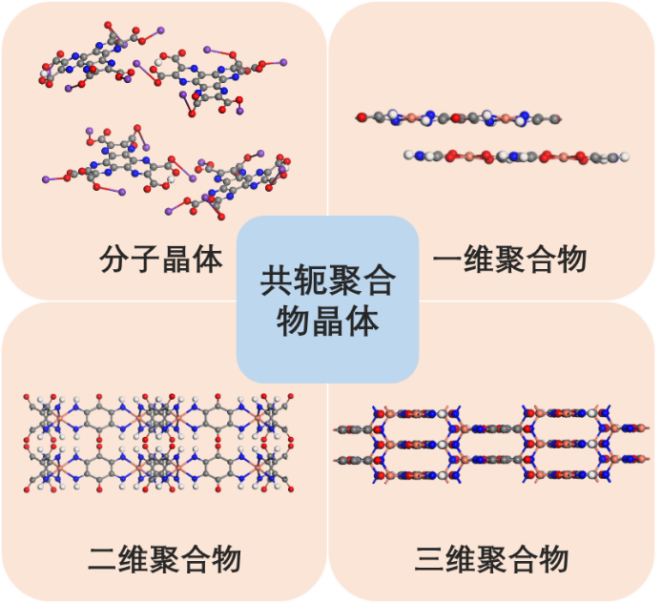

|  |  |  |  |  |
| --- | --- | --- | --- | --- |
| **Num.** | **Name** | **Preview** | **Reference**  **(should be cited)** | **Download Link** |
| 1 | 1D-CuTABQ |  | Kun Fan, Cheng Fu, Yuan Chen, Chenyang Zhang, Guoqun Zhang, Linnan Guan, Minglei Mao, Jing Ma, Wenping Hu, Chengliang Wang*, Framework Dimensional Control Boosting Charge Storage in Conjugated Coordination Polymers. *Adv. Sci.* **2022**, 220576. | 1D-CuTABQ.cif |
| 2 | 2D-CuTABQ |  | Kun Fan, Cheng Fu, Yuan Chen, Chenyang Zhang, Guoqun Zhang, Linnan Guan, Minglei Mao, Jing Ma, Wenping Hu, Chengliang Wang*, Framework Dimensional Control Boosting Charge Storage in Conjugated Coordination Polymers. *Adv. Sci.* **2022**, 220576. | 2D-CuTABQ.cif |
| 3 | 3D-CuTAPT |  | Kun Fan#, Jian Li#, Yongshan Xu, Cheng Fu, Yuan Chen, Chenyang Zhang, Guoqun Zhang, Jing Ma, Tianyou Zhai, Chengliang Wang*, Single crystals of a highly conductive three-dimensional conjugated coordination polymer. *J. Am. Chem. Soc.* **2023**, 10.1021/jacs.3c02378. | 3D-CuTAPT.cif |
| 4 | HAT-5COOK_Model A |  | Jincheng Zou#, Cheng Fu#, Yong Zhang#, Kun Fan, Yuan Chen, Chenyang Zhang, Guoqun Zhang, Huichao Dai, Yueyue Cao, Jing Ma*, Chengliang Wang*, A Novel Hexaazatriphenylene Carboxylate with Compatible Binder as Anode for High-Performance Organic Potassium-Ion Batteries. *Adv. Funct. Mater.* **2023**, 202303678. | HAT-5COOK_Model A.cif |
| 5 | HAT-5COOK_Model B |  | Jincheng Zou#, Cheng Fu#, Yong Zhang#, Kun Fan, Yuan Chen, Chenyang Zhang, Guoqun Zhang, Huichao Dai, Yueyue Cao, Jing Ma*, Chengliang Wang*, A Novel Hexaazatriphenylene Carboxylate with Compatible Binder as Anode for High-Performance Organic Potassium-Ion Batteries. *Adv. Funct. Mater.* **2023**, 202303678. | HAT-5COOK_Model B.cif |
| 6 | HAT-5COOK_Model C |  | Jincheng Zou#, Cheng Fu#, Yong Zhang#, Kun Fan, Yuan Chen, Chenyang Zhang, Guoqun Zhang, Huichao Dai, Yueyue Cao, Jing Ma*, Chengliang Wang*, A Novel Hexaazatriphenylene Carboxylate with Compatible Binder as Anode for High-Performance Organic Potassium-Ion Batteries. *Adv. Funct. Mater.* **2023**, 202303678. | HAT-5COOK_Model C.cif |
| 7 | HAT-5COOK_Model D |  | Jincheng Zou#, Cheng Fu#, Yong Zhang#, Kun Fan, Yuan Chen, Chenyang Zhang, Guoqun Zhang, Huichao Dai, Yueyue Cao, Jing Ma*, Chengliang Wang*, A Novel Hexaazatriphenylene Carboxylate with Compatible Binder as Anode for High-Performance Organic Potassium-Ion Batteries. *Adv. Funct. Mater.* **2023**, 202303678. | HAT-5COOK_Model D.cif |
| 8 | HAT-5COOK_Model E |  | Jincheng Zou#, Cheng Fu#, Yong Zhang#, Kun Fan, Yuan Chen, Chenyang Zhang, Guoqun Zhang, Huichao Dai, Yueyue Cao, Jing Ma*, Chengliang Wang*, A Novel Hexaazatriphenylene Carboxylate with Compatible Binder as Anode for High-Performance Organic Potassium-Ion Batteries. *Adv. Funct. Mater.* **2023**, 202303678. | HAT-5COOK_Model E.cif |